**Simulation :** PMOS

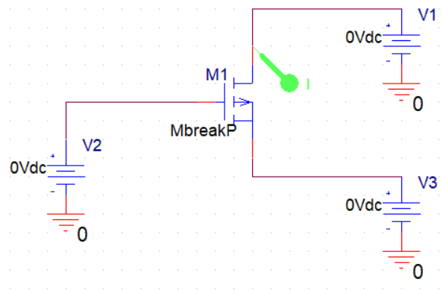

**Figure :** Circuit Diagram for PMOS.

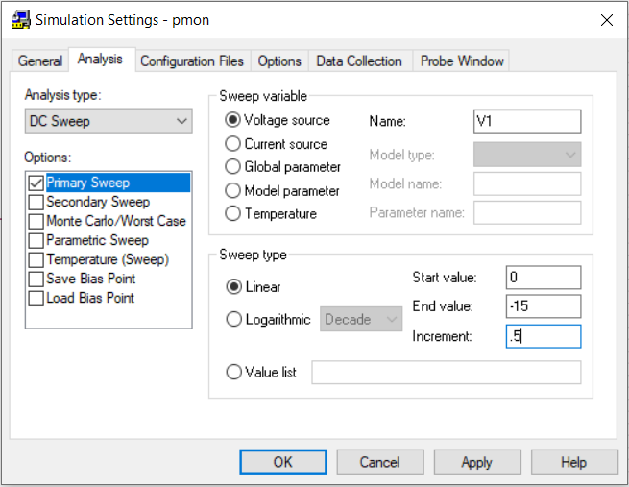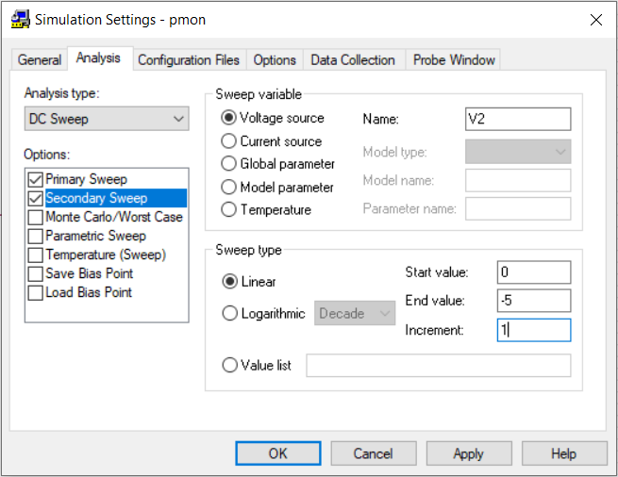

**Figure :** Input for PMOS.

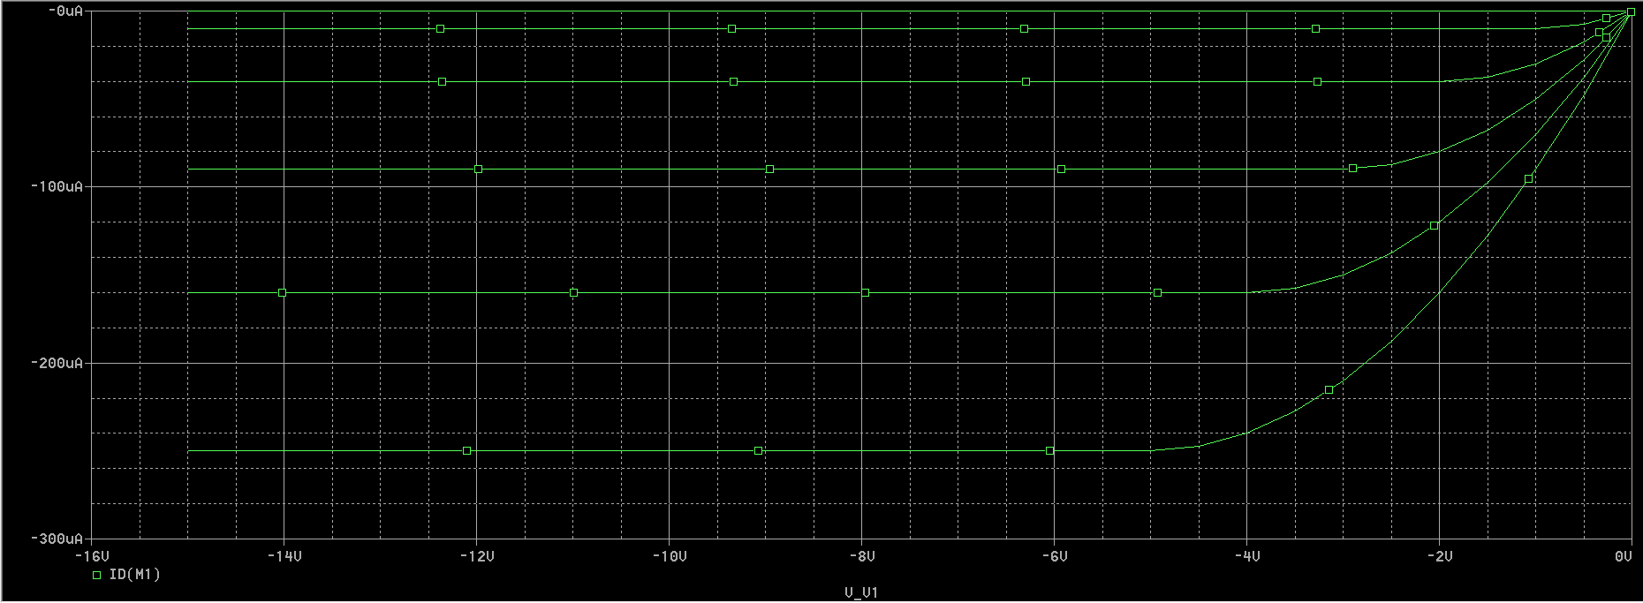

**Figure :** Resultant Curve for PMOS.